

**EVALUATION OF INTERNSHIP REPORT**

## B.Tech: III Year

**Department of Computer Science & Information Technology**

**Name of the Student: Honey Sharma**

**Branch & section: CSIT-2**

**Roll No: 0827CI201078**

**Year: 2022-2023**

## Department of Computer Science & Information Technology

**AITR, Indore,**

**ACROPOLIS INSTITUTE OF TECHNOLOGY & RESEARCH, INDORE**

# Department of Computer Science & Information Technology

**Certificate**

Certified that training work entitled “Cyber Security ” is a bonafied work carried out after sixth semester by *Honey Sharma* in partial fulfilment for the award of the degree of Bachelor of Technology in Computer Science and Information Technology from *Prof. Nidhi Nigam* Acropolis Institute of Technology and Research during the academic year 2022-23.

*Prof. Nidhi Nigam*

**ACROPOLIS INSTITUTE OF TECHNOLOGY & RESEARCH, INDORE**

# Department of Computer Science & Information Technology

**ACKNOWLEDGEMENT**

I would like to acknowledge the contributions of the following people without whose help and guidance this report would not have been completed. I acknowledge the counsel and support of our training **Prof. Nidhi Nigam** , CSIT Department, with respect and gratitude, whose expertise, guidance, support, encouragement, and enthusiasm has made this report possible. Their feedback vastly improved the quality of this report and provided an enthralling experience. I am indeed proud and fortunate to be supported by him/her. I am also thankful to Dr. Shilpa Bhalerao, H.O.D of Computer Science Information Technology Department, for her constant encouragement, valuable suggestions and moral support and blessings. Although it is not possible to name individually, I shall ever remain indebted to the faculty members of CSIT Department, for their persistent support and cooperation extended during this work.

*Honey Sharma*

*0827CI201078*

### ACROPOLIS INSTITUTE OF TECHNOLOGY & RESEARCH, INDORE

### INDEX

S.no CONTENTS Page no

1. Introduction to technology Undertaken 1

2. Objectives 3

3. Project undertaken ……………………….. 4

4. Screenshots of Project and Certificates……………………….. 11

5. Github Links (Project/certificate/video/copy of report.… ……. 12

7. Conclusion……….. ……………………………………. 16

8. References/ Bibilography………………………………..…………… 17

* **Introduction to technology Undertaken :**

Cyber security ,CIPHER algorithm

* **Objective:**

Cryptography is the practice and study of techniques for secure communication in the presence of third parties called adversaries. More generally, cryptography is about constructing and analyzing protocols that prevent third parties or the public from reading private messages; various aspects in information security such as data confidentiality, data integrity, authentication, and non-repudiation are central to modern cryptography. Modern cryptography exists at the intersection of the disciplines of mathematics, computer science, electrical engineering, communication science, and physics. Applications of cryptography include electronic commerce, chip-based payment cards, digital currencies, computer passwords, and military communications.

* **Project Undertaken:**

**Encryption Decryption (Cipher Text)**

The primary purpose of encryption is to protect the confidentiality of digital data stored on computer systems or transmitted over the internet or any other computer network. In addition to security, the adoption of encryption is often driven by the need to meet compliance regulations.

The purpose of encryption is confidentiality concealing the content of the message by translating it into a code. The purpose of digital signatures is integrity and authenticity verifying the sender of a message and indicating that the content has not been changed.

Text Encryption is the method by which information is converted into secret code that hides the information’s true meaning. Cipher is an algorithm which is applied to plain text to get cipher text. It is the unreadable output of an encryption algorithm. The term “cipher” is sometimes used as an alternative term for cipher text.

Example:  
Let: A-Z = 1–26 , a-z = 27–53 , !=ex, @= adr

and let the numbers from 1–100 be the same (no change in that)

Therefore,  
“RAM” after encryption will be “18113” whereas  
“ram” will be “442739” and  
“@Ram13” will be “adr18273913”

* **Screenshots of Project and Certificates**

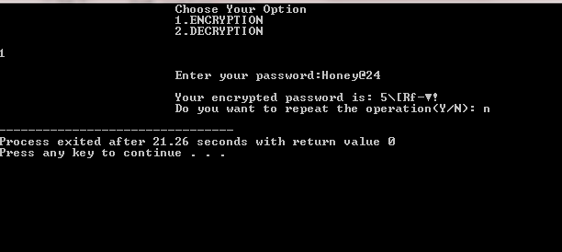

* **Certificates**

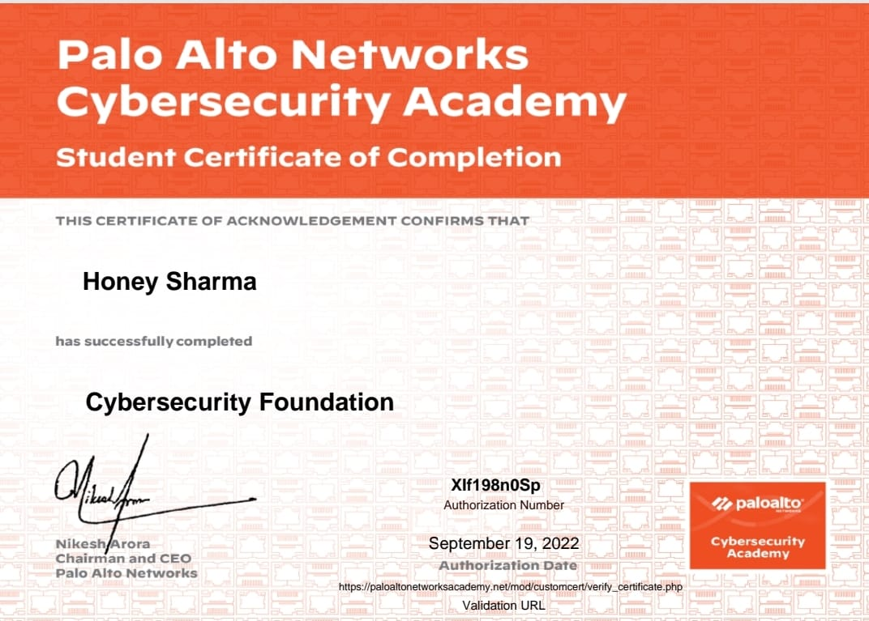

* **GitHub Links :**

https://github.com/honeyy02/Evaluation_of_Internship-EOI-

* **Conclusion**

Encryption is essential to keep private information, messages, and financial transactions private and secure in a digital world. It protects the confidentiality of digital data stored on computer systems or transmitted over the internet. Various types of encryption techniques are available including the Advanced Encryption Standard (AES), the gold standard for data encryption, used worldwide and the U.S. government standard.

* **References**

[www.google.com](http://www.google.com)

[www.youtube.com](http://www.youtube.com)

<https://en.wikipedia.org/wiki/Computer_security>